Installation:

npm install --save-dev webpack

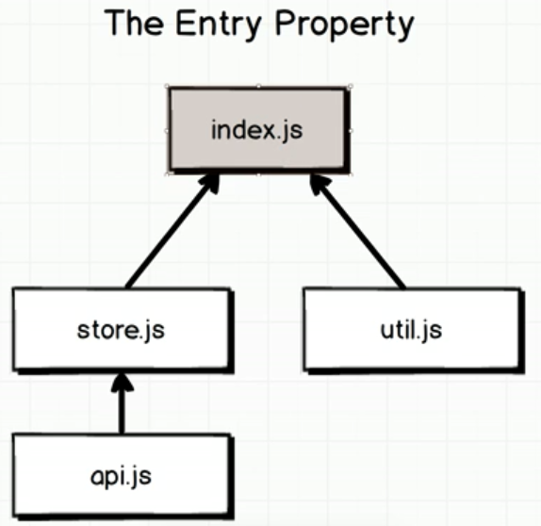

Webpack active the entry point and the JS tree will be called accrodingly.

Create a config.js file:

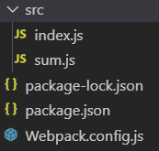

write inside:

// node.js path getter

const path = require('**path**');

const config = {

**// where to run the project**

    entry:'./src/index.js'

    output:{

**// get a absolute path of current file, call the bundled file 'bundle.js', put file inside a folder 'build'**

        path:path.resolve(__dirname,'build'),

        filename:'bundle.js'

    }

}

module.exports = config;